Chapter 10: Testing in a Variable Environment

# Mini Abstract

1-2 paragraph chapter description. Should generally go over contents, expectations, and results. Abstracts are usually the last part of something to be written out since it is a summary of the article, but we can use them here to help flesh out our ideas a bit for how to structure. Final abstract should be overhauled at the end of the chapter though, the chapter dictates the abstract, not the other way around.

Since testing in a controlled environment was not completed, we could not test in a variable environment.

# 

# Chapter Outline

Develop the chapter outline here. Should become very detailed and broken down to paragraph level. Remember, if we invest time and effort into making a detailed outline, the actual writing will be far easier since we understand the flow and structure before we lay out the details. Before even writing a subsection, take the time to outline that subsection in the chapter outline. A lot of writing is in the layout. Remember to update this chapter in the Master Outline file so we can all keep track of the full outline of the report, its large so breaking it up this way should help everyone keep track of each other's ideas and work.

# Chapter 10 Draft

Testing in a variable environment was unable to be conducted due the incomplete state of the system. We wanted to fully test the system in a controlled environment in order to make sure we had complete control and verification of many of our systems functions before moving on to a variable environment. Since the controlled environment testing was not completed testing in an variable environment was never attempted, however This chapter will go discuss the tests and procedures we would have used to verify our systems use in a variable environment.

## 10.1 Variable Environment Tests

In this section we will introduce the proposed tests that we would have attempted in order to verify our systems use in a variable environment, namly outside. These tests would mostly be focused around stress testing our closed loop R.C. and Autonomous functionality and their ability to verify their respective technical requirements STR 3.0.0, Remote Control, & STR 4.0.0, Autonomous. Additionally these tests would have helped confirm that STR1.0.0, Flight Time, and STR 2.0.0, Drone Speed, are achievable in an uncontrolled environment.

10.1.1 Closed Loop R.C. Testing

Once verified in a controlled environment such as the flight room at Westside Research Park, A closed loop control flight test would be conducted outside in order to determine if STR 3.0.0, Remote Control, could be met when we have no control over the weather or obstacles that the system may encounter. This would have our system fly using our closed loop control system, it would determine if our system was successfully able to maintain stable pitch and rolla angles within ±0.1 radians, while maintaining a stable height of 1±0.15m. While dealing with the natural terrain and wind patterns of the area, the test is conducted. The uncontrolled wind conditions would help us further verify the STR 2.0.0, Drone Speed, as the wind direction would vary and test conditions that we had not tested in our controlled test. Additionally the closed loop control may respond in unique ways to the uncontrolled wind and terrain. This could vary the power draw of our system in unforeseen ways, so this test would further help STR 1.0.0, Flight Time. Since this test will be conducted outside the length of the tether used to hold the drone would be increased, so that drone could maneuver over a large area while still maintaining the security against the loss of the system a tether provides. The procedure of this potential test is shown in Figure 10.1.

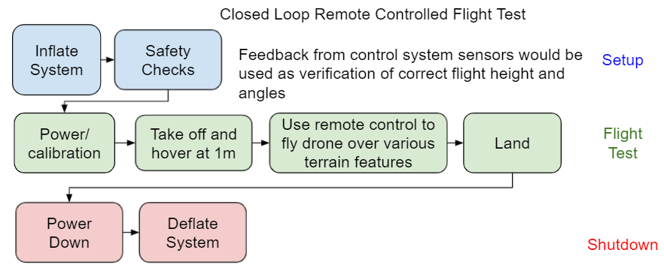

Fig. 10.1. Procedure Flow Chart for Closed Loop RC Flight Test

Since the telemetry system available at Westside Research park will not be available for this test, Subsystem requirements STR3.1.0, System Response, and STR 3.2.0, Data Feedback, must be fully verified in order to maintain safe and controlled flight as well as collect valid from the control system sensors as these will provide us with our systems telemetry data allowing us to verify the success or failure of the test flight.

10.1.2 Autonomous Test

After the closed loop control of the system is verified in an uncontrolled environment, a similar test can be performed with our drones system on autonomous control. In addition to the closed loop remote control flight test confirming the ability of our system to fly in an uncontrolled environment, it is critical that switch from autonomous to RC STD3.3.0 is fully verified, as in the event of the loss of control of our system, it is essential that we regain control of system as soon as possible. Similarly to the closed loop remote control test this test will help verify both STR 1.0.0, Flight Time, as well as STR 2.0.0, Drone Speed, by allowing us to see how our autonomous flight system responds to uncontrolled environmental obstacles, terrain, and wind. We can determine if these requirements are still met even in the uncontrolled environment that may cause our drone to respond in ways not found in controlled testing. This test will also be used to further verify STR 4.0.0, Autonomous by seeing that our drones required telemetry holds even in uncontrolled conditions. For this test to be conducted STR 4.4.0, Data Feedback, must be verified before hand, as similar to the closed loop control test the telemetry system at Westside Research park will not be available, so receiving data feedback about the systems telemetry during the flight test is essential to the verification of if the test was success or failure. The procedures of this proposed test can be seen in Figure 10.2

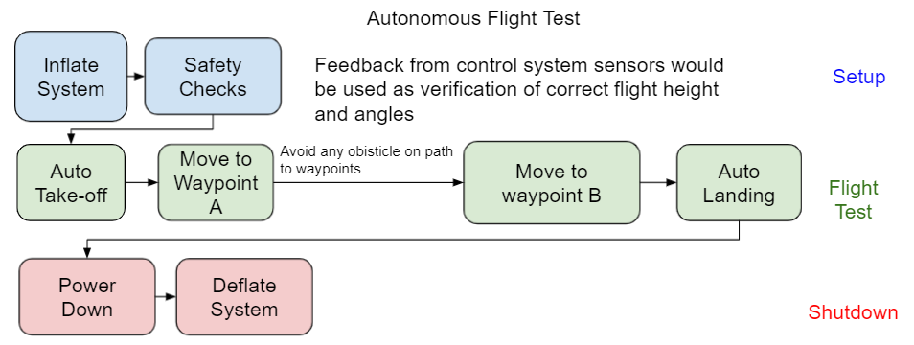

Fig. 10.2. Autonomous Flight Test

## 10.2 Conclusion

Although these tests were not conducted within the duration of our project, The verification methods of our requirements were planned out, as well as the steps needed to be taken before the verification process could start. This is important as it gives a clear path of how work on this project could be continued.

# 

# Chapter Bibliography

We do have a full bibliography that should absolutely be updated with all content here. The point of the chapter bibliography is to help keep track of citations in the chapter since the numbering may change in the full bibliography with changes and additions. This way will isolate the sources in this section so you can cite here without having to worry about it, and can use a simple find and replace on your citations to update the new numbering when we combine everything in the final report.